**Software Requirements Specification**

1. **Preface**

The intended readers for this document are the AI and Web development teams, to aid in their own development processes. This document corresponds to the first week of the project, for producing version 1.0, and it’s based on the initial requirements of the client.

1. **Introduction**

This document lays out a project plan for the development of an application for Android based on artificial intelligence capable of recognizing the number of roses in an image given by the user. The document includes the following sections: glossary, user requirements, system requirements, functional and non-functional system requirements and form-based structured requirements specification.

1. **Glossary**

| AI | Artificial Intelligence. |
| --- | --- |
| ETA | Estimated Time of Arrival. |
| Inference | In AI, an inference means that the model, based on the knowledge obtained in the training phase, deduces and finds conclusions from new data. |
| Bounding box | A bounding box is the smallest rectangle with vertical and horizontal sides that completely surrounds an object. |

1. **User Requirements**
   1. The mobile application shall receive a photo and count the number of roses in said photo.
   2. The photo shall be provided by the user, either from the phone’s camera or photo gallery.
2. **System Requirements**
   1. The system shall have a clean and intuitive user interface and user experience. The goal of this application shall be to act as a layer of communication between the user and the AI team system.
   2. The backbone of the system shall be provided by the AI team. This includes models, code, packages and documentation. Continuous communication between the AI and mobile teams is necessary.
   3. The inferences shall be executed using the AI team system and the photo provided by the user.
   4. The system should ask the user if they want to save the resulting image in their phone, and present an option to select another photo for inference or repeat the inference with the same image.
3. **Functional Requirements**
   1. The system shall ask initial permissions for camera and storage.
   2. An user shall be able to select an image for their photo gallery or take one from their phone’s camera, which shall be stored within the system.
   3. If the file selected from storage is not an image, the system shall tell that to the user, and prompt them to select again.
   4. The option to go back one step shall be always available.
   5. The inference step shall be cancellable at any moment if the user requires it.
   6. The system should show an ETA or progress rate for the inference.
   7. If the inference process raises any errors, the system shall be capable of handling them.
   8. The output for the system shall be an edited version of the image provided by the user, containing the bounding boxes that resulted for the inference. Additionally, the total count shall be presented to the user.
   9. If the user does not choose to repeat the inference with the same image, then the original stored image is deleted from the system.
4. **Non-functional Requirements**
   1. The total processing time for the inference step shall not be more than 3 seconds more than the execution time for the inference code.
   2. All steps that are not inference shall have response times of not more than 1 second, except for the image loading, which depends on the image size.
   3. The system shall process just one image at a time.
   4. The images provided to the system shall not exceed 10 Mb of size.
5. **Form-based structured requirements specification.**

*Roses images detection and count mobile software (RIDAC-MS)*

| **Function** | Detects and counts roses from a given image. |
| --- | --- |
| **Description** | Application for Android based on artificial intelligence capable of recognizing the number of roses in an image given by the user. |
| **Inputs** | Image provided by the user. |
| **Source** | Phone’s camera or phone’s photo gallery. |
| **Outputs** | An edited version of the image provided by the user, containing the bounding boxes that resulted for the inference and the total count of roses that those bounding boxes mark out. |
| **Destination** | Phone’s screen and memory storage, depending on if the user saves the inferred image. |
| **Action** | The edited version of the original image will be the same if this does not contain any rose that can be detected and counted, and the total count will be zero. If the original image has X number of roses, the edited image will contain X number of bounding boxes marking out those roses, and the total count will be X. |
| **Requirements** | The provided image should not exceed 10 Mb of size. |
| **Pre-condition** | None. |
| **Post-condition** | None. |
| **Side-effects** | None. |

1. **Signatures of the Development Team**

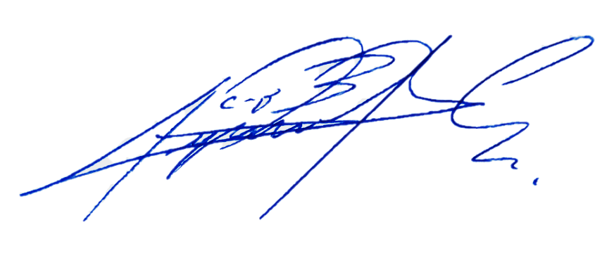

__________________________ _________________________

Stadyn Román Argenis Andrade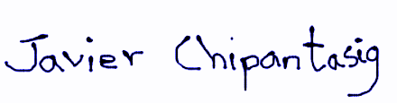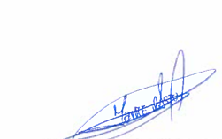

__________________________ _________________________

Javier Chipantasig Jaime Astudillo

**Unified Modelling Language (UML) diagrams:**

1. **Activity model**

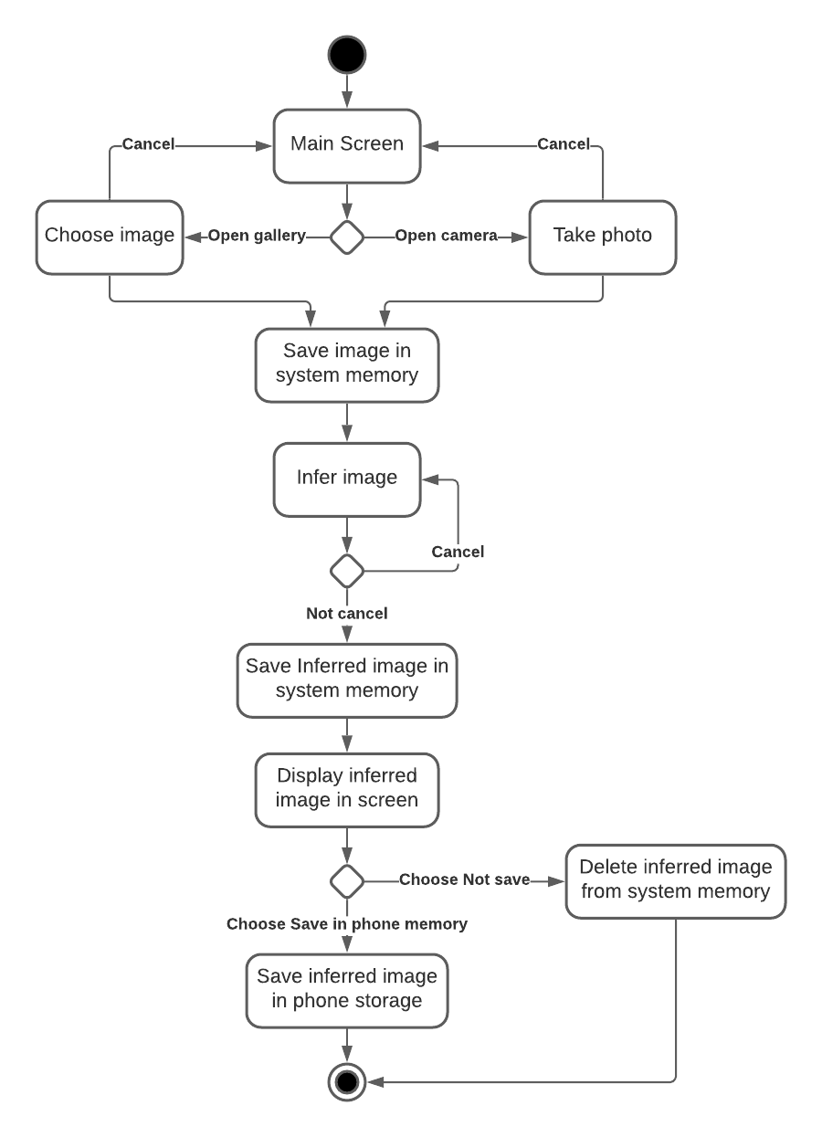

1. **Use case model**
2. **Load image from gallery**

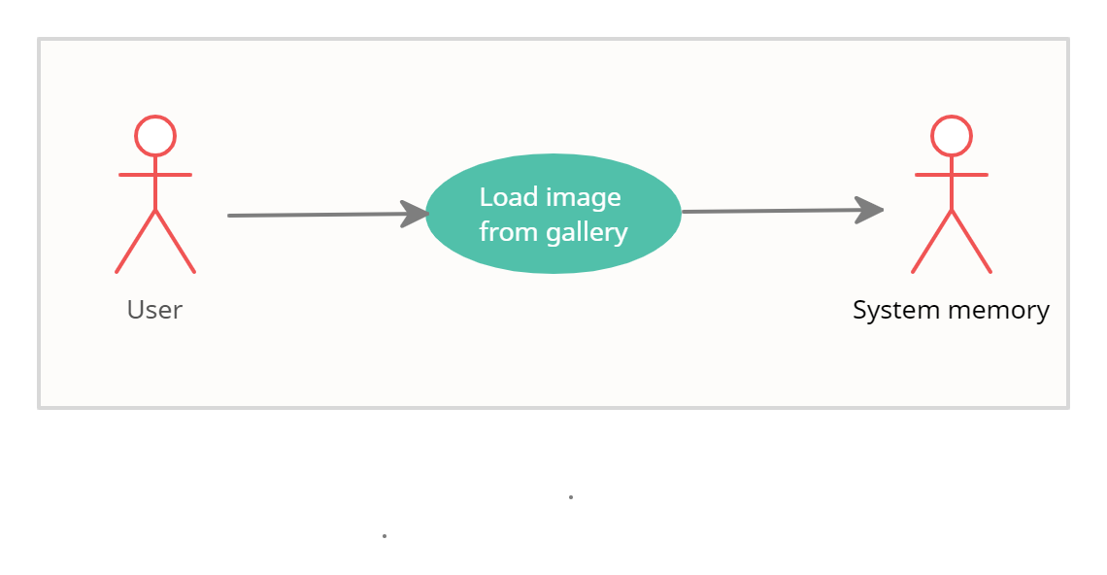

| **RIDAC-MS: Load image from gallery** | |
| --- | --- |
| Actors | User, System memory |
| Description | An user may select and load an image from the cellphone’s gallery to the memory of the mobile system. The image loaded may either contain roses or not contain roses. |
| Data | Image available in cellphone’s gallery |
| Stimulus | Command issued by user |
| Response | Confirmation that image has been loaded |
| Comments | There must be at least one image available in the cellphone's gallery.  The mobile app must have appropriate security permissions to access the cellphone's gallery. |

1. **Infer selected image**

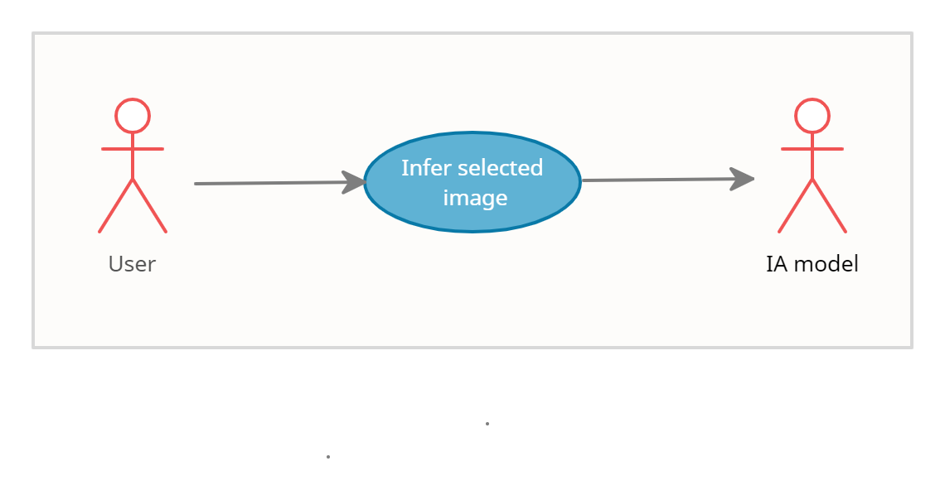

| **RIDAC-MS: Infer Selected Image** | |
| --- | --- |
| Actors | User, AI model |
| Description | An user may confirm that the loaded image is going to be inferred by the AI model. The AI model may process the image in order to return the inferred image. |
| Data | Image loaded in system memory |
| Stimulus | Command issued by user |
| Response | An edited version of the loaded image, containing the bounding boxes that resulted for the inference and the total count of roses that those bounding boxes mark out. Confirmation that the inferred image is loaded in system memory and is ready to be displayed on screen. |
| Comments | User may cancel inference in any time |

1. **Save inferred image**

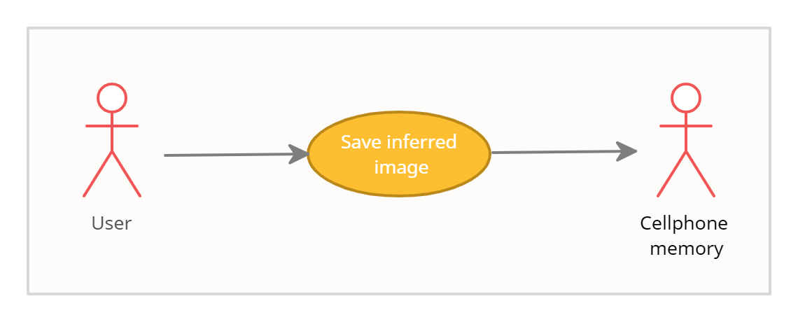

| **RIDAC-MS: Save inferred image** | |
| --- | --- |
| Actors | User, Cellphone’s memory |
| Description | An user may save the inferred image in the cell phone's memory. The user may select the directory where to store the image or the system should create a directory for inferred images. |
| Data | Inferred image loaded in system memory |
| Stimulus | Command issued by user |
| Response | Confirmation that Inferred image is saved in Cellphone’s memory |
| Comments | The mobile app must have appropriate security permissions to access the cellphone's memory and store data.  Cellphone's memory must have available space to store the inferred image |

1. **Sequence model**

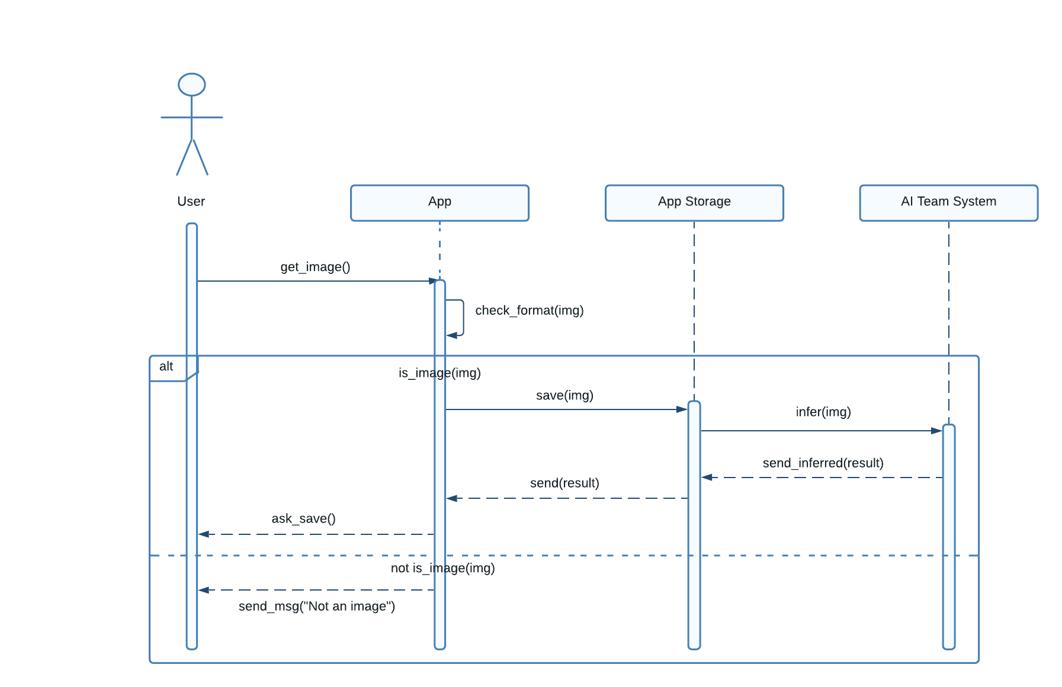

1. **Class model** 
   1. **Load image from gallery**

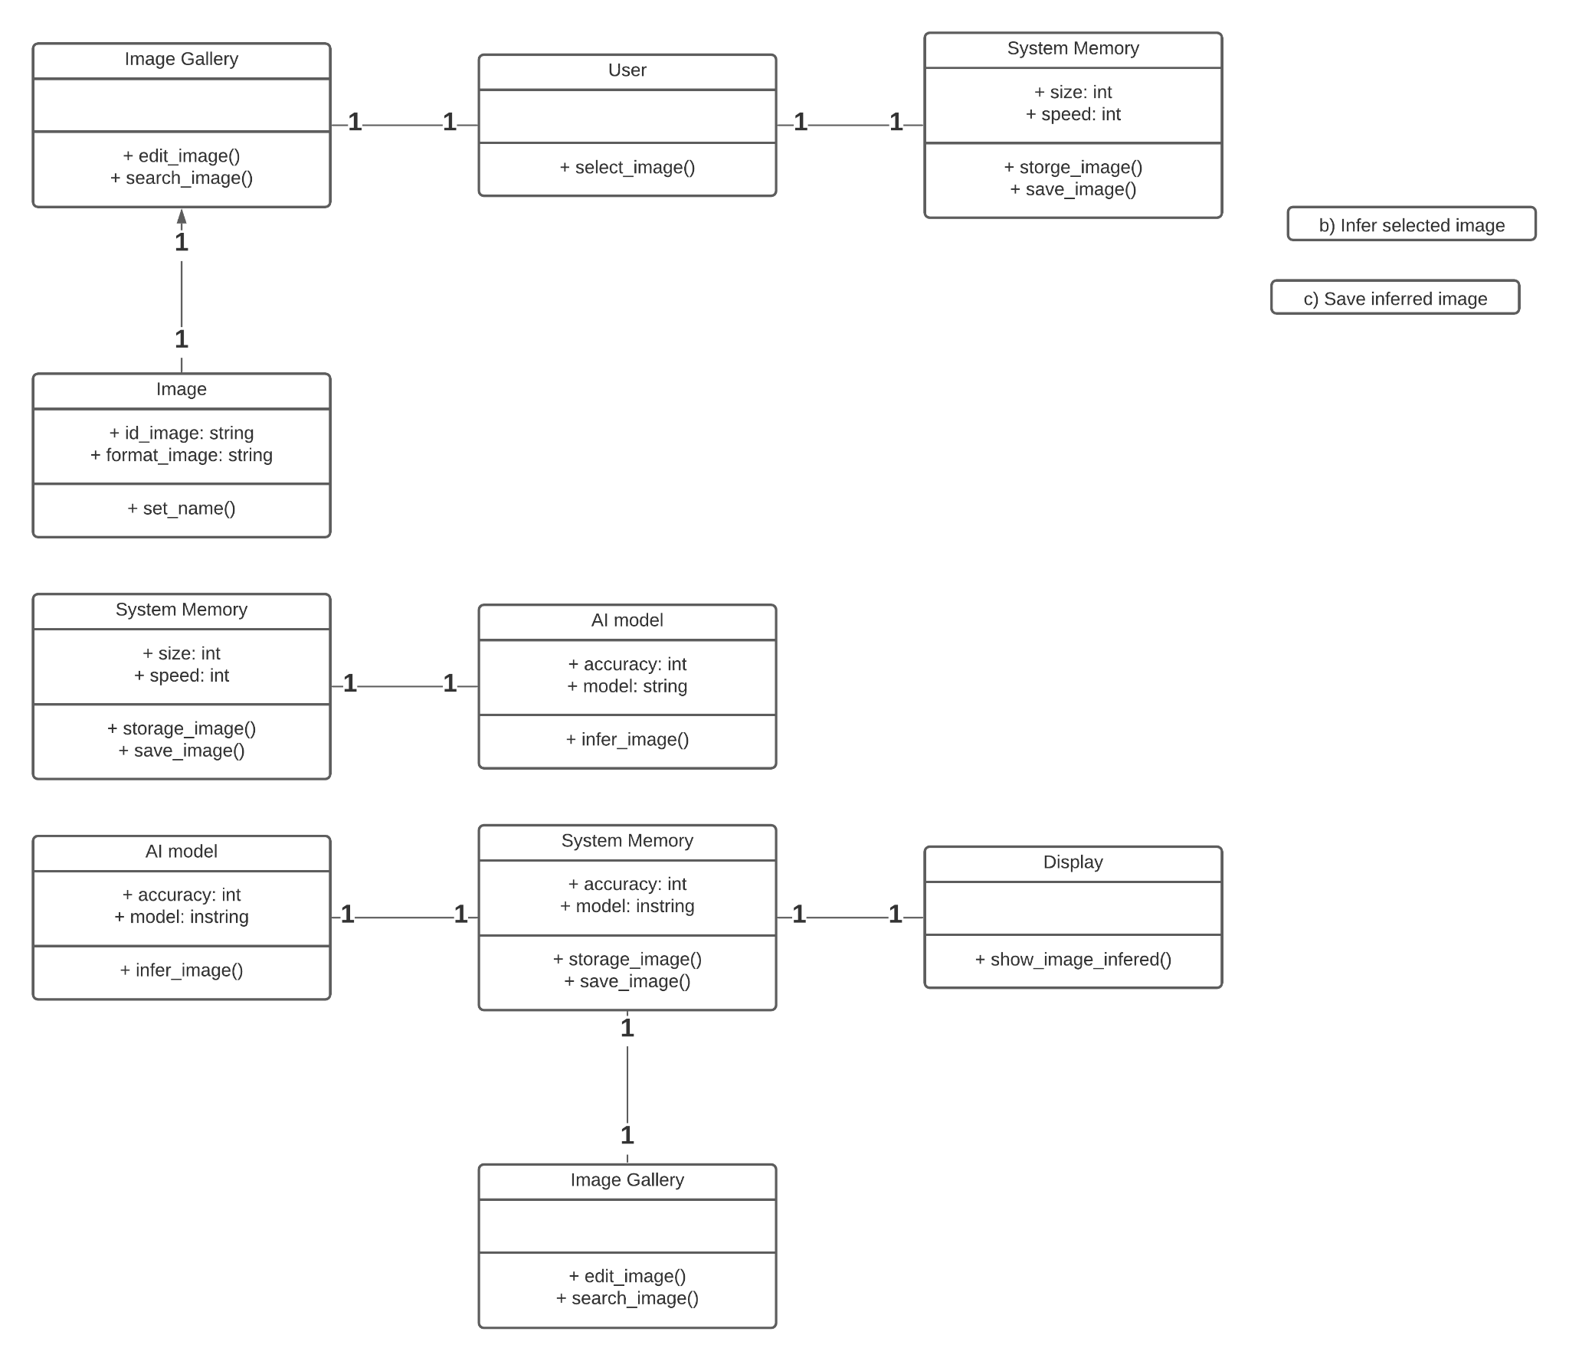

* 1. **Infer selected image**

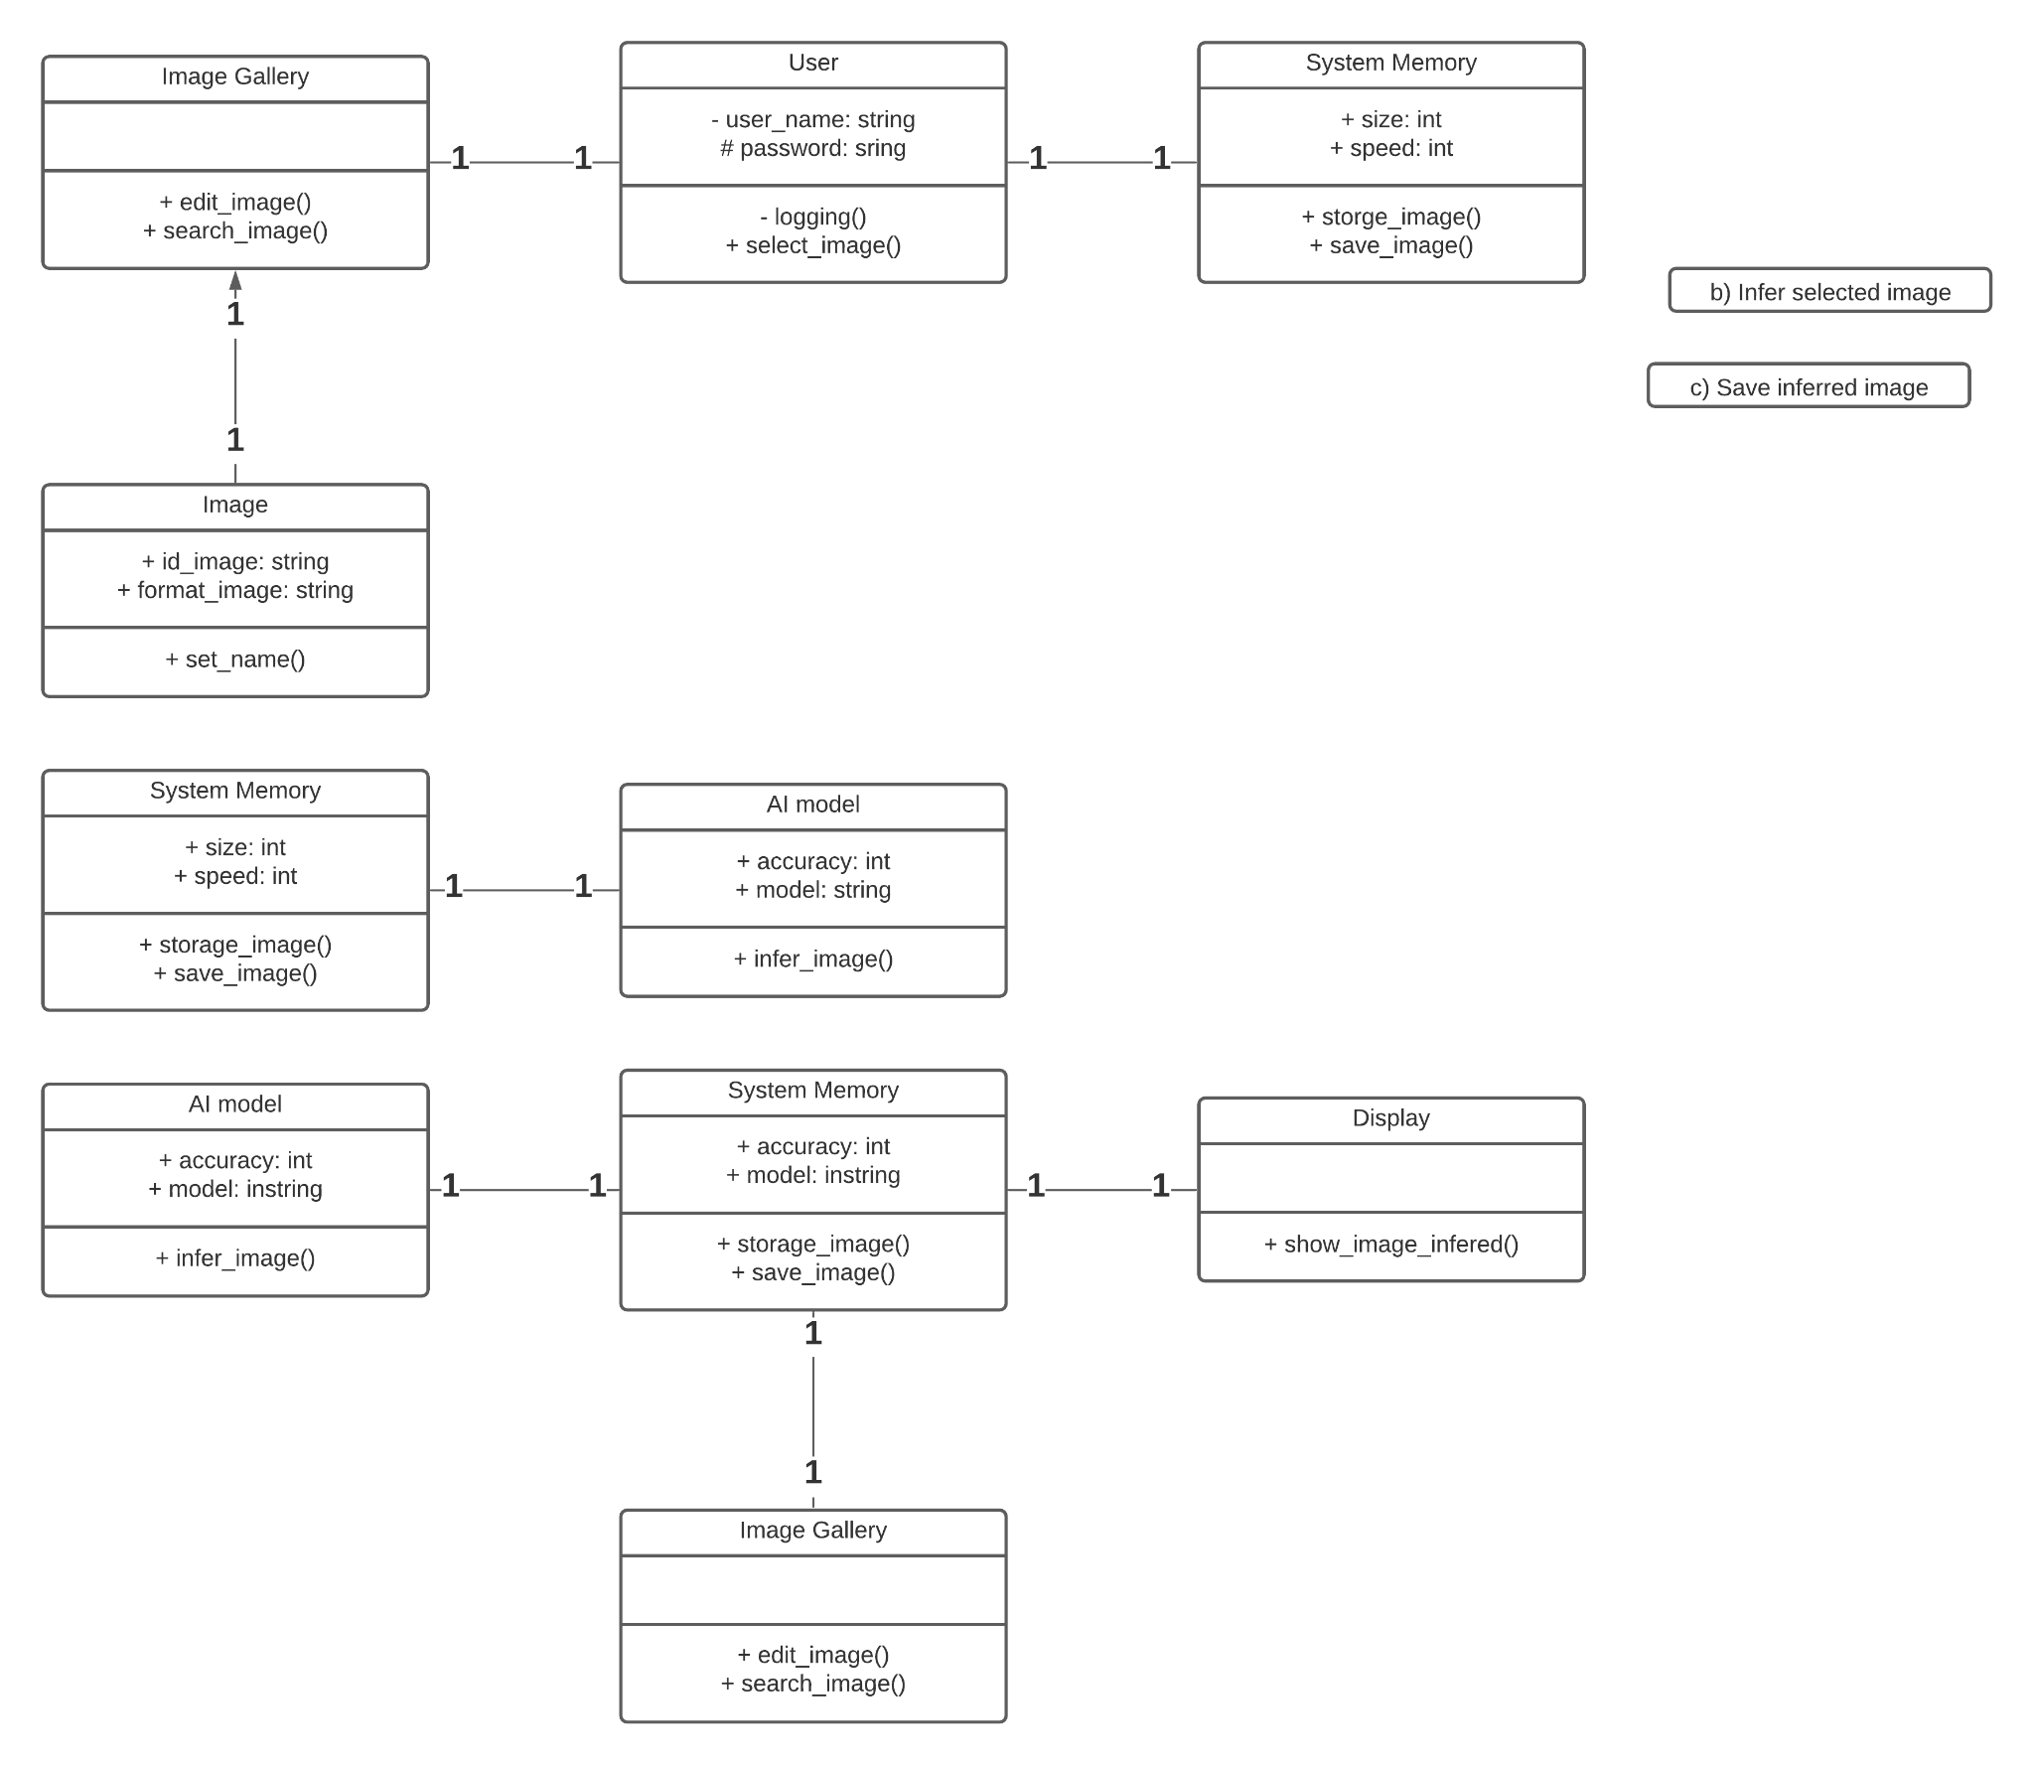

* 1. **Save inferred image**



1. **State model**

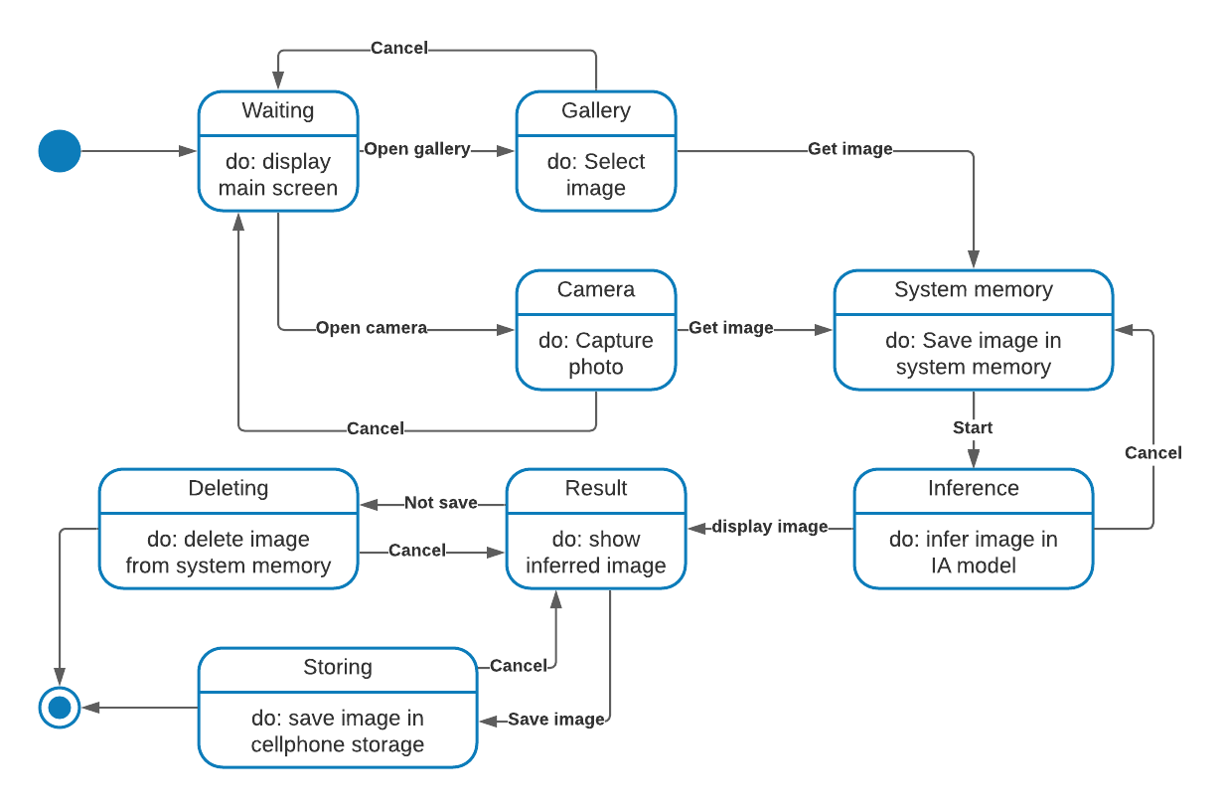

| **State** | **Description** |
| --- | --- |
| Waiting | The system is waiting for input |
| Gallery | The system is in the cellphone gallery |
| Camera | The system is in the cellphone camera |
| System Memory | The selected image is in the system memory |
| Inference | The system is making the inference with the AI model |
| Result | The system is displaying the inferred image in screen |
| Deleting | The system is deleting the inferred image |
| Storing | The system is saving the inferred image in the cellphone storage |

| **Stimulus** | **Description** |
| --- | --- |
| Open gallery | The user has pressed the gallery button |
| Open camera | The user has pressed the camera button |
| Get image | The user has selected the image |
| Display image | The user has pressed the display result button |
| Not save | The user has pressed the discard result button |
| Save image | The user has pressed the save result button |
| Start | The user has pressed the Start button. |
| Cancel | The user has pressed the Cancel button |

**Layered-design of the architecture of the system**

